

Course Title:
Computer Networks
Semester Project Report
Project Title: School Network Design And Implementation Using Cisco Packet Tracer
Submitted By:
Urooj Fatima (243558)
Fizza Naeem (243782)
Umme Ruman (243566)
BsCS F-24 (A)
Submitted To:
Saqib Imran

Department of Computer Sciences
Table of Contents
Project Background and Overview 3
Project Objectives 3
Network Design 3
VLAN Configuration 4
VLSM Implementation 5
Inter-VLAN Routing 5
OSPF Routing Configuration 6
Benefits of OSPF 6
DHCP Configuration 6
Benefits of DHCP 6
DNS and Email Services 6
Internet Connectivity and NAT 7
Security Implementation 7
Access Control Lists (ACLs) 7
Port Security 7
Wireless Network Configuration 8
Testing and Verification 8
Challenges Faced 12
Future Enhancements 12
Conclusion 13
References 13

Project Background and Overview
This project focuses on the design and implementation of a school network using Cisco Packet Tracer. The aim was to develop a secure, organized, and efficient network infrastructure for different departments within an educational institution. VLANs were used to separate departmental traffic, while VLSM was implemented for efficient IP address allocation. OSPF was configured for dynamic routing between routers, and NAT was used to provide internet access. Additional services such as DHCP, DNS, Email, and Web services were also deployed. To improve network security, Access Control Lists (ACLs) and Port Security were configured. The completed network was successfully tested and met all project requirements.
Computer networks play a vital role in modern educational institutions by supporting communication, information sharing, internet access, and administrative operations. A well-designed network improves performance, enhances security, and simplifies network management. The purpose of this project was to design and implement a campus network that connects multiple departments while ensuring secure communication and efficient use of network resources. Cisco Packet Tracer was used to build, configure, and test the entire network.

Project Objectives
The main objectives of this project were:
- To design a campus network for multiple departments.
- To implement VLANs for separating departmental traffic.
- To use VLSM for efficient IP address allocation.
- To configure Inter-VLAN Routing for communication between VLANs.
- To implement OSPF dynamic routing between routers.
- To provide internet access through NAT.
- To configure DHCP for automatic IP assignment.
- To deploy DNS and Email services.
- To implement ACLs for network security.
- To configure Port Security against unauthorized access.
- To provide wireless connectivity for users.

Network Design
The campus network was designed using the following devices:
- 5 Routers
- 1 Core Layer-3 Switch
- 5 Access Switches
- DNS Server
- Email Server
- Web Server
- Wireless Access Point
- Wired and Wireless End Devices
The network was divided into the following departments:
- Administration
- Laboratory
- Library
- Staff
- Students
- Examination
- Accounts
Each department was assigned a separate VLAN to reduce unnecessary broadcast traffic and improve network security.
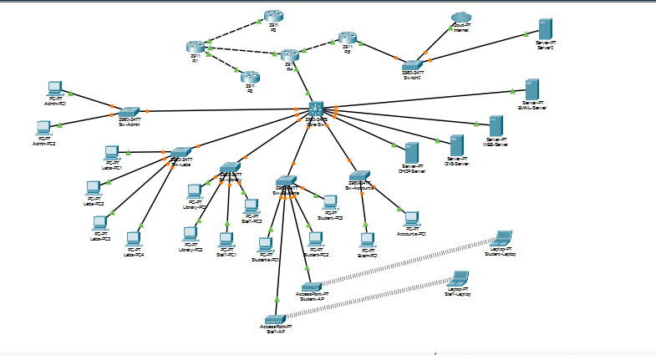
Figure: Network Topology

VLAN Configuration
The following VLANs were created:
VLAN ID | Department
10 | Administration
20 | Laboratory
30 | Library
40 | Staff
50 | Students
60 | Examination
70 | Accounts
Each VLAN was assigned its own subnet and default gateway for proper communication.

VLSM Implementation
Variable Length Subnet Masking (VLSM) was used to make efficient use of available IP addresses.
Network Address:
192.168.20.0/24
The address space was divided according to the requirements of each department. This approach minimized IP address wastage and provided flexibility for future network expansion.

Inter-VLAN Routing
A Layer-3 Core Switch was configured to perform Inter-VLAN Routing.
Switch Virtual Interfaces (SVIs) were created for each VLAN, allowing devices in different VLANs to communicate whenever permitted by network policies.
Example Default Gateways:
- VLAN 10 → 192.168.20.1
- VLAN 20 → 192.168.20.33
- VLAN 30 → 192.168.20.65
- VLAN 40 → 192.168.20.97
- VLAN 50 → 192.168.20.129
- VLAN 60 → 192.168.20.193
- VLAN 70 → 192.168.20.209

OSPF Routing Configuration
Open Shortest Path First (OSPF) was configured on all routers to enable dynamic routing throughout the network.
OSPF was selected because it automatically exchanges routing information between routers and quickly adapts to network changes.

Benefits of OSPF
- Automatic route learning
- Fast convergence
- Better scalability
- Reduced administrative effort
OSPF neighbor relationships were successfully established and verified during testing.

DHCP Configuration
DHCP was configured to automatically assign IP addresses to client devices.

Benefits of DHCP
- Reduces manual configuration
- Prevents IP address conflicts
- Simplifies network administration
All client devices successfully obtained IP addresses from the DHCP server.

DNS and Email Services
A DNS Server was configured to provide hostname-to-IP address resolution within the network.
An Email Server was also configured to allow communication between users from different departments.
User accounts were created for:
- Admin
- Lab
- Library
- Staff
- Student
- Examination
- Accounts
- Student Laptop
- Staff Laptop
Successful email communication between users was verified during testing.

Internet Connectivity and NAT
A simulated internet connection was established through Router R5.
Network Address Translation (NAT) was configured to allow internal private IP addresses to access external networks.
Testing confirmed that users from different departments were able to access internet resources successfully.

Security Implementation

Access Control Lists (ACLs)
ACLs were configured on the Core Switch to control communication between departments.
Examples include:
- Students were restricted from accessing Administration devices.
- Students were restricted from accessing Examination devices.
- Students were restricted from accessing Accounts devices.
- Students were allowed access to essential services such as DNS and Email servers.
These restrictions improved overall network security while maintaining access to required services.

Port Security
Port Security was implemented on access switch ports using the following features:
- Sticky MAC Address Learning
- Maximum MAC Address Limit
- Shutdown Violation Mode
This configuration helps prevent unauthorized devices from connecting to the network.

Wireless Network Configuration
A wireless access point was configured to provide wireless connectivity.
Wireless devices included:
- Student Laptop
- Staff Laptop
Both devices successfully connected to the wireless network and received valid IP addresses automatically.
Wireless communication and access to network services were tested successfully.

Testing and Verification
The following tests were performed to verify network functionality:
VLAN Communication (Ping from Admin-PC1 to Library-PC1)
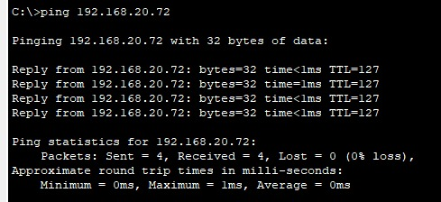

VLSM verification (on Core Switch)
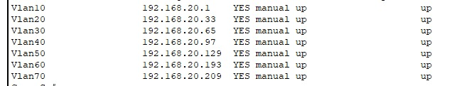

OSPF Verification (Testing on R1)
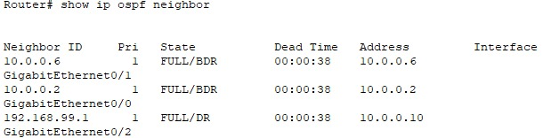
OSPF Verification
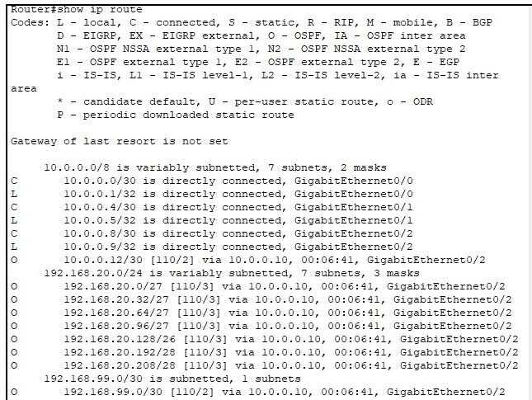
Internet Connectivity (Test from Student-PC1)
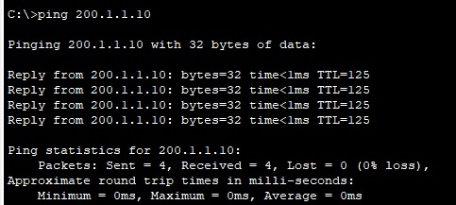
DNS verification (Test from Student-PC1)
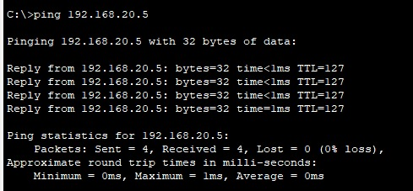
Email Verification (Sent from Student Laptop to Staff Laptop)
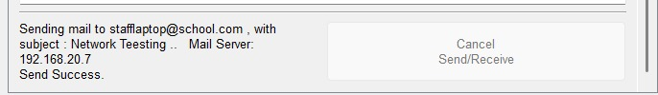
Email received at Staff Laptop
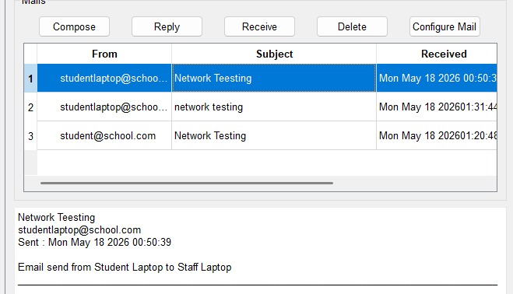

ACL verification
ACL blocking services (From Student-PC1 to Admin-PC)
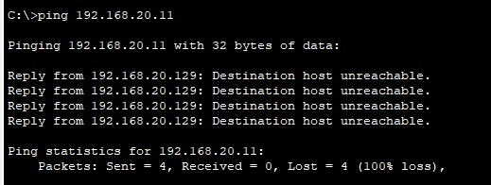
ACL allowing services (From Student-PC1 to Email Server)
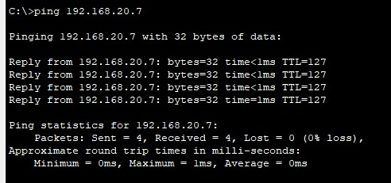
Port Security verification (on Admin switch)
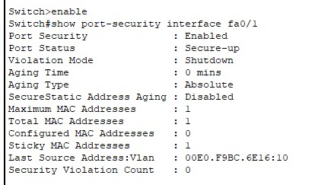

Wireless verification(Student Laptop , VLAN 50 address)
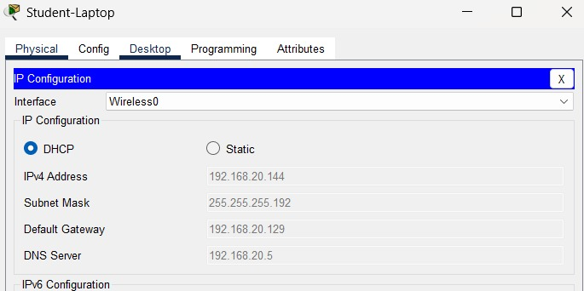
All tests produced the expected results and confirmed that the network was functioning correctly.

Challenges Faced
Several challenges were encountered during the implementation process, including:
- OSPF neighbor formation issues
- ACL configuration errors
- Email communication problems
- Wireless VLAN assignment issues
These issues were identified through testing and resolved through troubleshooting, configuration verification, and network analysis.

Future Enhancements
Although the network was successfully implemented, there are several improvements that can be made in the future:
- Expand the network to support more users and departments.
- Improve security by adding a firewall and advanced monitoring tools.
- Upgrade to IPv6 for better scalability.
- Increase wireless coverage across the campus.
- Implement backup links to improve network reliability.
- Add centralized network management for easier monitoring and troubleshooting.
These enhancements would help make the network more secure, reliable, and suitable for future growth.

Conclusion
This project successfully demonstrated the design and implementation of a secure and efficient campus network using Cisco Packet Tracer. Technologies including VLANs, VLSM, OSPF, NAT, DHCP, DNS, Email services, ACLs, Port Security, and Wireless Networking were configured and tested successfully.
The final network provides secure communication, efficient resource utilization, centralized management, and reliable internet connectivity for all departments. In addition, the project provided valuable practical experience in network design, configuration, troubleshooting, and security implementation.
Overall, all project objectives were achieved successfully.

References
- Cisco Networking Academy Resources
- Cisco Packet Tracer Documentation
- Cisco OSPF Configuration Guide
- Computer Networking Fundamentals Course Materials
- TCP/IP Networking Reference Material

